# Caremark.com – Open and Closed Tickets Reference Sheet

Reference Sheet

Open Issues Tab

Closed Issues Tab

Related Documents

**Description:** Caremark.com Open and Closed Tickets ReferenceSheet is a report designed to help Customer Care Representatives (CCRs) assist members with website functionality concerns. It provides the most up-to-date information for known issues affecting the Caremark.com website and/or mobile app causing the most member impact.

|  |
| --- |
| **Reference Sheet** |

**Note:** Screen captures might not match the actual scenario for this process. Some clients may not opt into specific web features. This work instruction/job aid is intended as a guide only.

Click here to access the [Caremark.com - Open and Closed Tickets Reference Sheet (004662)](https://thesource.cvshealth.com/nuxeo/thesource/#!/view?docid=26d618f5-befc-454e-a59b-fda85b8563fd).

The reference document is broken into two (2) sheets:

* The **Open Issues** tab contains information pertaining to Caremark.com issues that have already been reported and are being researched.
* The **Closed Tickets** tab contains information pertaining to tickets that have been resolved.

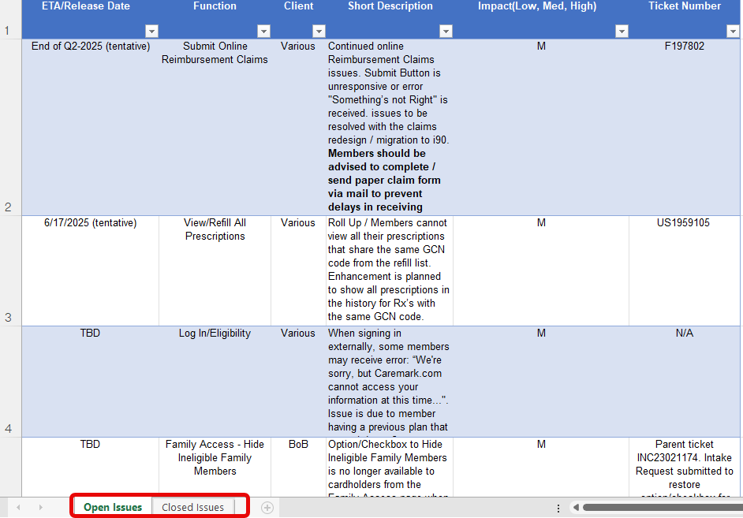

Top of the Document

|  |
| --- |
| **Open Issues Tab** |

Utilize this sheet to determine whether the web support issue/error a member is reporting is a known issue.

Click the **Open Issues** tab.

The sheet is updated frequently with:

1. **ETA/Release Date:** Estimated date an issue will be resolved.
2. **Function:** Affected site and/or application.
3. **Client:** Affected by the issue.
4. **Short Description:** Description of issue impacting members.
5. **Impact:** Level (Low, Med, High).
6. **Ticket Numbe**r **or Defect Number**: Assigned to research and resolve issue.

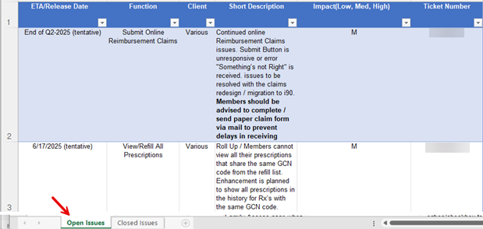

Top of the Document

|  |
| --- |
| **Closed Issues Tab** |

Utilize this sheet to determine whether a web support issue/error the member has experienced has been resolved.

Click the **Closed Issues** tab.

This sheet is updated frequently with:

1. **ETA/Release Date:** Date issue has been resolved.

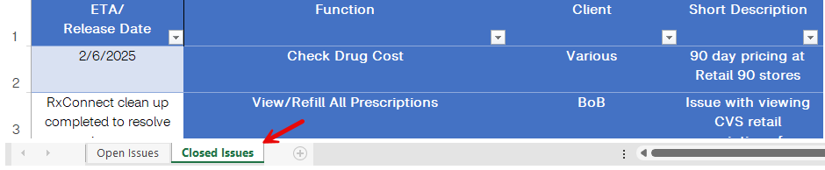

Top of the Document

|  |
| --- |
| Related Documents |

**Parent Document:** [CALL 0045 Customer Care Web Support Email Response and Handling](https://policy.corp.cvscaremark.com/pnp/faces/DocRenderer?documentId=CALL-0045)

[CALL 0011 Authenticating Caller](https://policy.corp.cvscaremark.com/pnp/faces/DocRenderer?documentId=CALL-0011)

[Customer Care Abbreviations, Definitions, and Terms (017428)](https://thesource.cvshealth.com/nuxeo/thesource/#!/view?docid=c1f1028b-e42c-4b4f-a4cf-cc0b42c91606)

**Index:** [Caremark.com - Work Instruction/Job Aid Index (105672)](https://thesource.cvshealth.com/nuxeo/thesource/#!/view?docid=8a2da44a-6336-454d-8deb-fca4a71ad69b)

Top of the Document

Not To Be Reproduced Or Disclosed to Others Without Prior Written Approval

**ELECTRONIC DATA = OFFICIAL VERSION – PAPER COPY – INFORMATIONAL ONLY**